***1 SHABAN JUMA***

***HSB212-0020/2022***

***BIOCHEMISTRY AND MOLECULAR BIOLOGY***

***2 NELLY NYAMBURA***

***HSB214-0372/2022***

***MEDICAL BIOCHEMISTRY***

***3 TABITHA NYAWIRA***

***HSB214-0079/2022***

***MEDICAL BIOCHEMISTRY***

***THE FINAL REPORT FOR PHYSICAL CHEMISTRY SEMESTER ONE 2023 BIOCHEMISTRY DEPARTMENT 2023***

The unit physical chemistry was one of the seven units undertaken in the semester and several achievements were made

1. All practical reports were submitted before the half of the semester
2. The two cats were well done with more than half scoring above the pass mark
3. The physical chemistry summit organized by the department was successful

The following department members took part in the summit and were all awarded

|  |  |  |
| --- | --- | --- |
| **Name** | Course | Award |
| Nelly Nyambura | Medical Biochemistry | Full Scholarship |
| Shaban Juma | Biochemistry and molecular Biology | A trip to Cambridge University |
| Tabby Nyawira | Medical Biochemistry | Full internship at KEMRI |

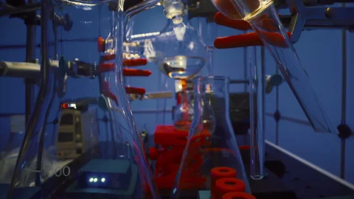

“The department also employed a few staff members and new equipment was purchased by the donors. A big appreciation

for the government of Kiambu for supplying some of the forensics biological equipment to the department”

The Chairman Biochemistry Department

Professor Ahmad bin Zain

The students also took their time to study the Gas Laws in a broad way. The gas laws include Charles’ law, Boyle’s law and Hess laws and they summarized the equation as

$$f\left(a\right)=\frac{1}{2πⅈ}\oint{\frac{f\left(z\right)}{z-a}dz}$$

From the equation, the following conclusions were made

1.The rate of diffusion of a gas is directly proportional to its Molar Mass, rate of diffusion depends on;

I) Temperature

Ii) Size of particle

2.The volume of a gas remains constant at varying temperature

3.The size of the molecules is considered neglible

Based on the laboratory analysis of the gas laws, the department discovered that an error of 0.0003% accrued while calculating the individual results (this is the most accurate error in modern day Chemistry) The department also made discovery for the sources of error including

* Possible heat loss to the surrounding from the apparatus
* The environmental temperature is not accounted for
* The rate of reaction is assumed to be constant

This was a major breakthrough in the unit development and as a department, we hope that our discovery would be made aware globally

* The unit physical chemistry is set to be reviewed by the department and any necessary changes arising from the department discoveries shall be added into study and examination

Apart from the successful part, the department also experienced challenges in the physical chemistry study. The challenges were not that severe but we believe that physical chemistry would be easier if such challenges were neutralized

1. Many laboratories equipment upon breakage were not replaced
2. In availability of adequate water during physical chemistry practical
3. The manual in usage in the laboratory is not up to dateIK

**“No greater discovery was ever made with a bold guess**

**To every action, there is always opposed an equal reaction**

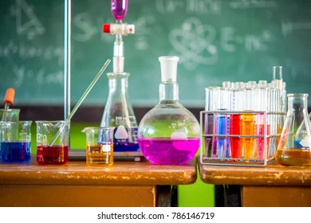

**Live your life as an exclamation rather than an explanation**

**ISSAC NEWTON**

**As a department, we wish you a Merry Christmas and a Happy New Year**